Mount Lawley Senior High School  
Year 8 Physical Sciences

***Energy Conservation and Efficiency Test***

**SECTION A: MULTIPLE CHOICE**

*Read all answers and choose the* ***BEST*** *one.*

1. ***Jordan watches a music video clip on his iPhone. Choose the best description of the energy  
    transformations that are happening.***
2. Electrical energy 🡪 sound energy + light energy + heat energy
3. Electrical energy 🡪 sound energy + light energy
4. Sound energy + light energy + heat energy 🡪 electrical energy
5. Sound energy + light energy 🡪 electrical energy
6. ***Select the correct energy flow diagram showing energy changes that occur when playing with a battery-operated fire truck that moves and sounds a siren.***
7. Electrical energy 🡪 kinetic energy + sound + heat
8. Chemical energy 🡪 sound + heat energy
9. Electrical energy 🡪 heat + elastic potential energy
10. Chemical energy 🡪 kinetic energy + sound + heat
11. **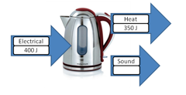 *Look at the diagram below and determine how much energy is transferred to sound energy:***

Heat

350J

1. 30J
2. 50J

Electrical

400J

1. 400J

Sound

1. 350J
2. ***What are some ways we can improve the energy efficiency of our homes?***

a) Ensure the switches are turned off when not using appliances.

b) Use more energy efficient appliances.

c) Use renewable energy sources such as solar panels.

d) All of the above.

1. ***An effective insulator traps heat. The effectiveness of three brands of thermos are shown below. An equal volume of water at 80° C was poured into each thermos. The temperature of the water was tested every 10 minutes. These temperatures in each thermos are shown in the table below.***

|  |  |  |  |  |
| --- | --- | --- | --- | --- |
| Time (mins) | Silvertop thermos | Geyser thermos | Thermocool thermos | Radiant thermos |
| 0 | 80 | 80 | 80 | 80 |
| 10 | 72 | 80 | 68 | 79 |
| 20 | 65 | 77 | 55 | 78 |
| 30 | 57 | 76 | 48 | 77 |
| 40 | 54 | 76 | 41 | 76 |
| 50 | 52 | 75 | 36 | 73 |
| 60 | 49 | 75 | 34 | 66 |

Based on the data in the above table, the most effective insulator is the:

1. Silvertop thermos
2. Geyser thermos
3. Thermocool thermos
4. Radiant thermos
5. ***If a food processor is 25% efficient, then for every 10 kJ input, its useful energy output is:***
6. 25 kJ
7. 75 kJ
8. 2.5 kJ
9. 7.5 kJ
10. ***When a battery powered torch is switched on the energy transformation is:***

a) Mechanical 🡪 chemical potential 🡪 light.

b) Kinetic energy 🡪 electrical 🡪 light.

c) Electrical energy 🡪 chemical potential 🡪 light.

d) Chemical potential 🡪 electrical 🡪 light.

1. ***Which of the following things cannot be measured accurately by everyday instruments?***

a) Height.

b) Weight.

c) Colour.

d) Length.

1. ***Using garden lights that use solar light energy to power them instead of fairy lights is an example of:***

a) Energy Conservation and Energy Transfer.

b) Energy Efficiency and Energy Transfer.

c) Energy Conservation and Energy Transformation.

d) Energy Efficiency and Energy Transformation.

1. ***Using LED lights instead of Light bulbs to convert electrical energy into light energy is an example of***:

a) Energy Conservation and Energy Transfer.

b) Energy Efficiency and Energy Transfer.

c) Energy Conservation and Energy Transformation.

d) Energy Efficiency and Energy Transformation.

1. ***A particular electric knife is 40% efficient. If 100 J of energy is supplied to the knife, the number of joules that is then transformed into kinetic energy is:***
2. 40
3. 100
4. 60
5. 140
6. ***If the efficiency of the Spinners washing machine is 40%, Sparkles washing machine is 35% and the Sprinkles washing machine is 52%, then the machines listed from most to least efficient are:***
7. Spinners, Sparkles, Sprinkles
8. Sparkles, Sprinkles, Spinners
9. Sprinkles, Spinners, Sparkles
10. Sparkles, Spinners, Sprinkles
11. ***The number of stars found on an Energy Rating Label indicates:***
12. The energy efficiency of an appliance.
13. How much energy the appliance will require to operate.
14. How much effort needs to be taken to maintain the appliance.
15. How easy the appliance is to clean.
16. ***Use your knowledge of energy transformations to match the transformation below with the correct situation:***

**Elastic potential energy → kinetic energy + sound energy + heat energy**

1. A girl toboggans down a slope.
2. You ride a bike.
3. A wind-up toy car travels across the floor.
4. A boy swims in a pool.
5. 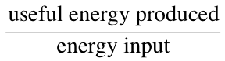***The efficiency of an appliance is the ratio of:***

If a food processor is 25% efficient, then for every 10 kJ input, its useful energy output is:

1. 25 kJ
2. 75 kJ
3. 2.5 kJ
4. 7.5 kJ

**SECTION B: SHORT ANSWER** **(20 marks)**

1.Use the diagram below to answer questions **a) to c):**

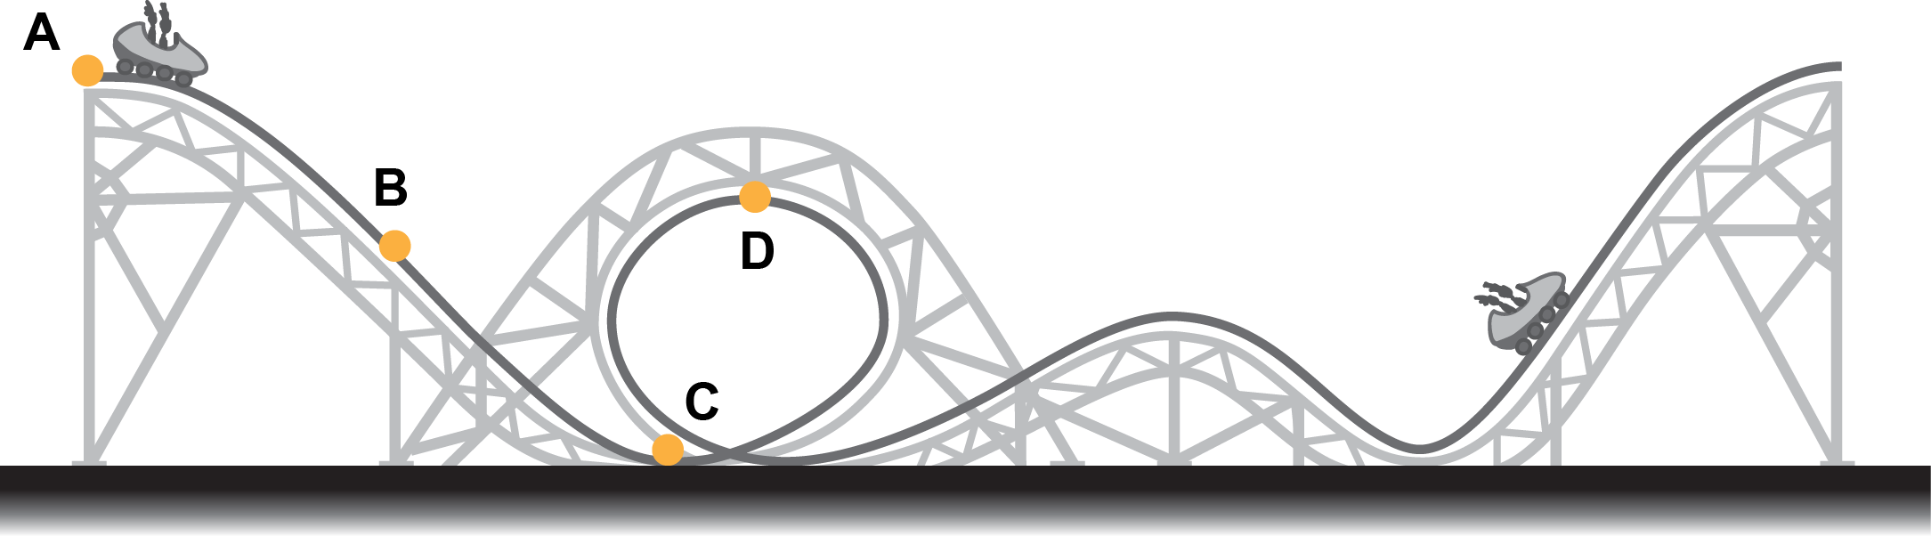

1. **Give** TWO **energy transformations** that occur as the rollercoaster car moves from Point A to Point C: **(2 marks)**

GPE 🡪 Kinetic (1 mark each)

GPE 🡪 Heat

GPE 🡪 Sound

1. **Give** an **energy transformation** that occurs as the rollercoaster car moves from Point C to Point D: **(1 mark)**

Kinetic 🡪 GPE

1. **Identify** TWO forms of wasted energy in this scenario: **(1 mark)**

Heat, Sound (0.5 marks each)

1. State The Law of Conservation of Energy: **(2 marks)**

Energy cannot be created or destroyed (1) it can only be transformed or transferred (1).

2. **Name** 2 devices that Transform chemical energy to heat energy: (2 marks)

|  |
| --- |
| **Gas stove, Gas water heater**  **Battery powered devices [battery is ½ mark]** |
|  |

3. What does the Law of Conservation of Energy **state**? (2 marks)

|  |
| --- |
| **Energy can not be destroyed or created (1) It can only be transformed or transferred (1)** |

4. A car uses 300 000J of chemical potential energy. Of that energy, 225 000J is transformed into wasted heat and  
 sound energy. *(1 mark each for a, b, c)* (3 marks)

|  |  |  |
| --- | --- | --- |
| a) **State** the formula used to calculate energy efficiency:  **Efficiency = Useful Output X 100**  **Total Input**  **75 000 / 300 000 = 0.25 x 100**  **= 25% ( -½ mark for no units)** | b) **Calculate** the amount of energy that is transformed into useful kinetic energy:  **300 000 – 225 000**  **= 75 000J ( -½ mark for no units)** | c) **Calculate** the the energy efficiency of this car: |

5. **Write** an energy flow diagram that shows all of the transformations and transfers taking place in the following scenario: A litre of water being heated in a kettle (with a whistle) on a gas stove.

*\* Be sure to include both the useful transformations and any energy that is wasted*. (7 marks)

**1 mark for each transformation. 1 mark for arrows included.**

**Chemical** potential **Heat** energy of **Heat** energy of **Heat** energy of water

energy of gas flame kettle and steam

**Heat/Light** energy **Sound** Energy

lost to air lost to air

6. James watches a television show after school.

a State the source of energy for the television. (1 mark)

electrical energy

b List any forms of energy that this energy is transformed into. (3 marks)

heat energy, sound energy, light energy

7a State whether a television can be 100% efficient. (1 mark)

no

b Explain your response. (2 marks)

**All devices produce some heat**. Because this heat is not required for the viewing of the television, it is unwanted energy. This means that some **electrical energy is wasted to produce this heat,** making the television less than 100% efficient.

8. Sienna turns around in a shop and her handbag knocks a vase from a stand. The vase falls and smashes on the floor.

a Recall the initial type of energy possessed by the vase. (1 mark)

gravitational potential energy

b State the name of the type of energy that this is transformed into as the vase falls. (1 mark)

kinetic energy

c Identify one other form of energy that is also transformed in this situation. (1 mark)

Some of the initial energy is also transformed into heat and sound energy as the vase falls and smashes on the floor.

9. Use the diagram below to construct an energy flow diagram showing the energy changes that occur when using a microwave oven if your energy supply is wind powered.

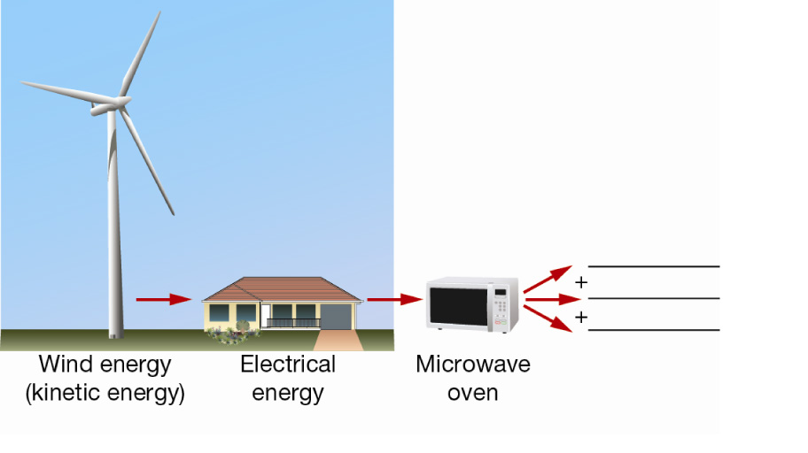

kinetic energy 🡪 electrical energy 🡪 kinetic energy + sound + heat energy (1 mark for copying diagram, 1 mark for arrows in right direction, 1 mark for light/heat/sound.)

10a List one useful forms of energy that are produced when you use an electric drill. (1 mark)

kinetic energy of the rotating drill bit

**b.** Identify two other forms of energy that are produced that are not useful. (2 marks)

heat and sound energy

10. The following table shows a recent estimate of a person’s daily energy consumption at various stages of civilisation.

|  |  |
| --- | --- |
| **Civilisation** | **Consumption per person per day (Kilojoules)** |
| Stone Age | 110 |
| Hunter gatherers | 340 |
| Advanced agriculture | 1090 |
| Industrial revolution | 3250 |
| Modern technology | 9600 |

Graph:

1 mark for title 1 mark for labelled axis 1 mark for neatness (ruler)

1 mark for correct units on axis 1 mark for correct graph (type & shape)

10a. According to your graph, what has happened to our daily energy consumption over the time period shown? (1 mark)

Increased

10d. A modern technological person consumes how much more energy compared to a person living in the industrial age (200 years ago)? 6350kJ (1 mark)

10e. Can you suggest 3 reasons why there has been a large rise in energy consumption since the advance of agriculture? (3 marks)

1 mark - more money to spend on food

1 mark - more food available

1 mark - energy content of food (junk)